CS 255 System Design Document Template

UML Diagrams

UML Use Case Diagram
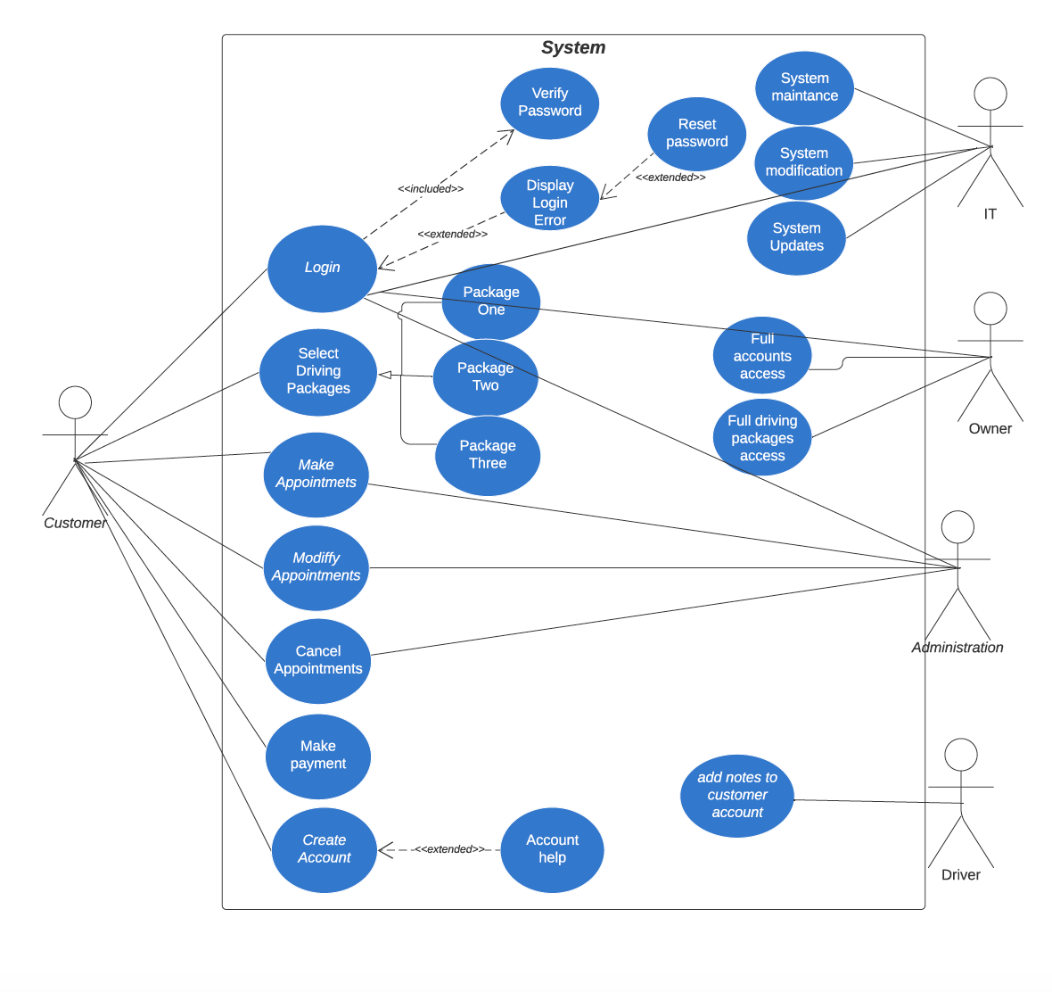

UML Activity Diagrams
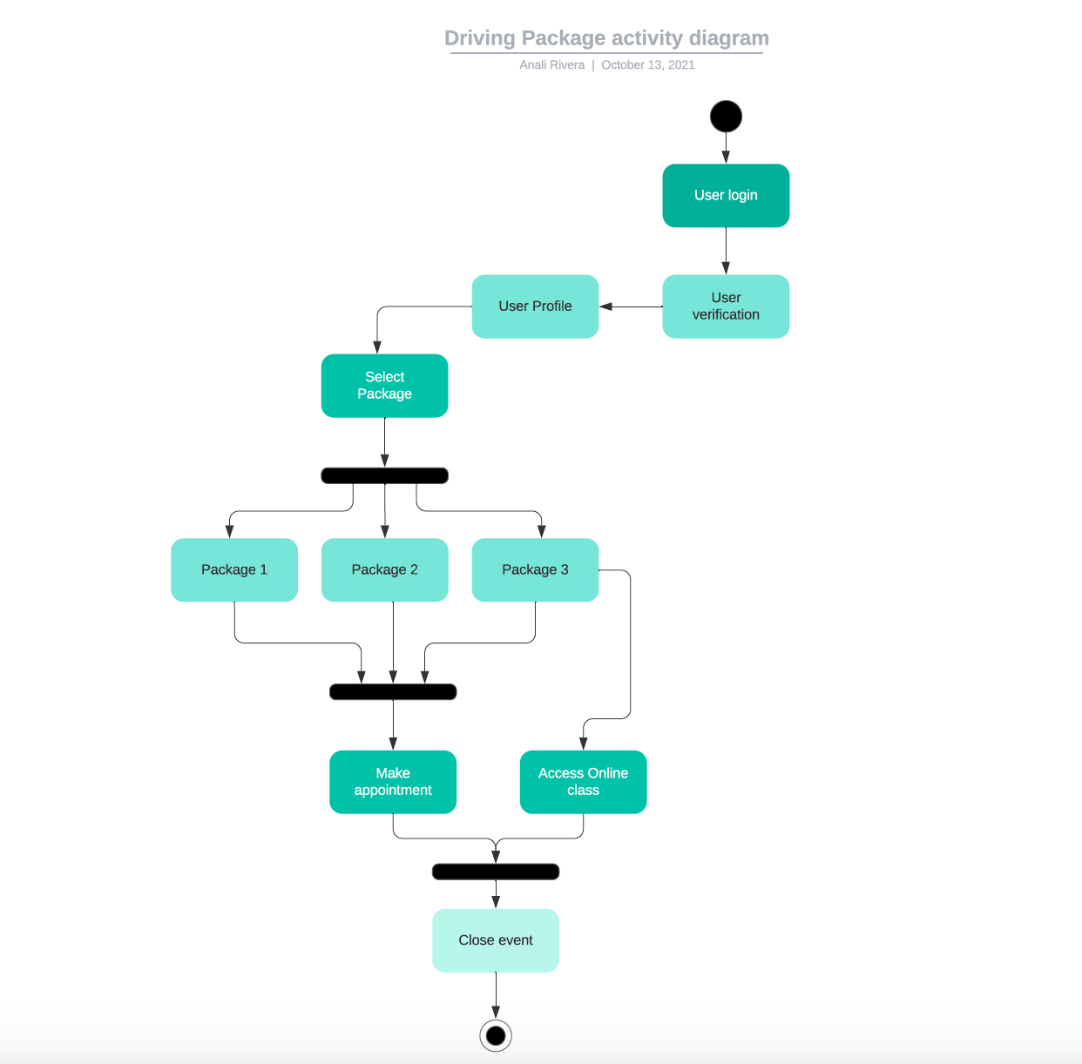

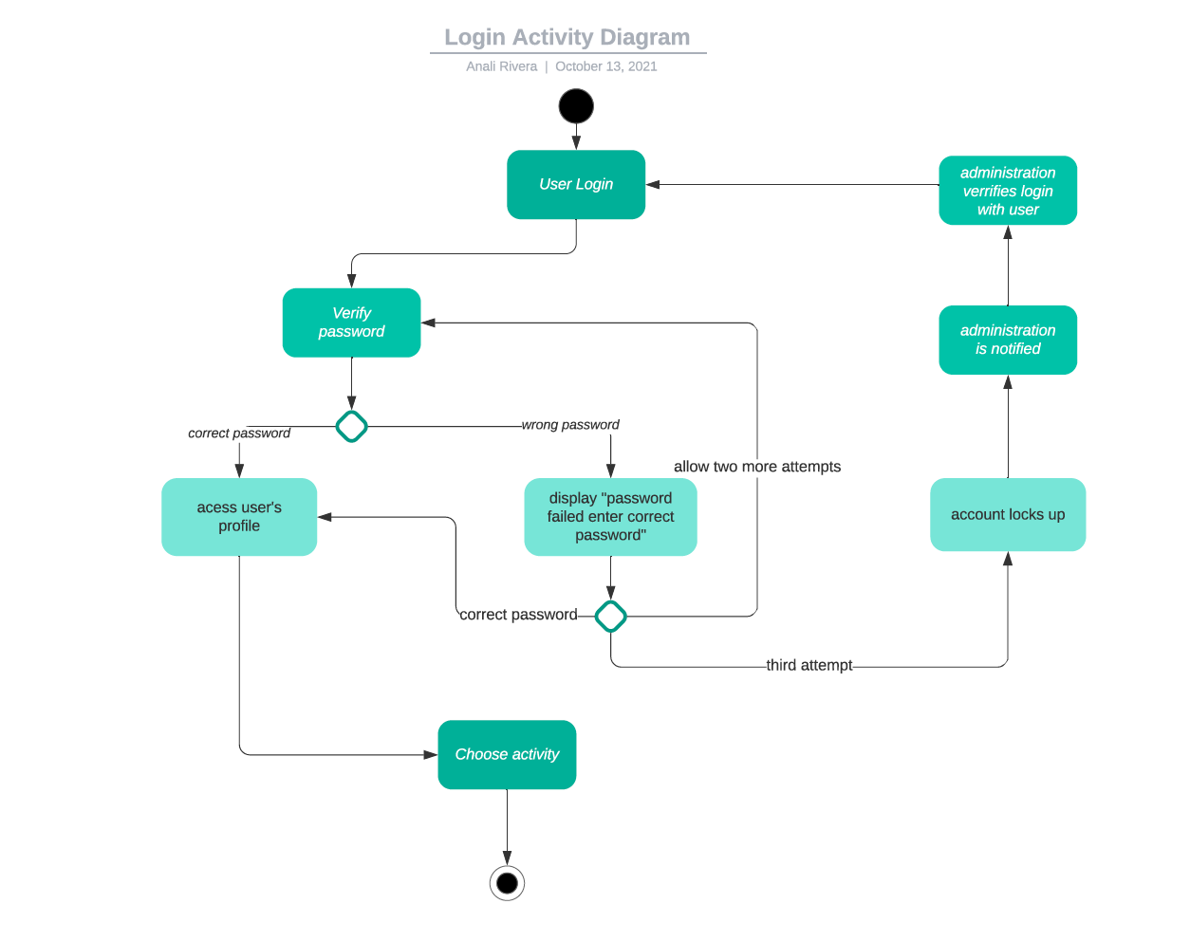

UML Sequence Diagram
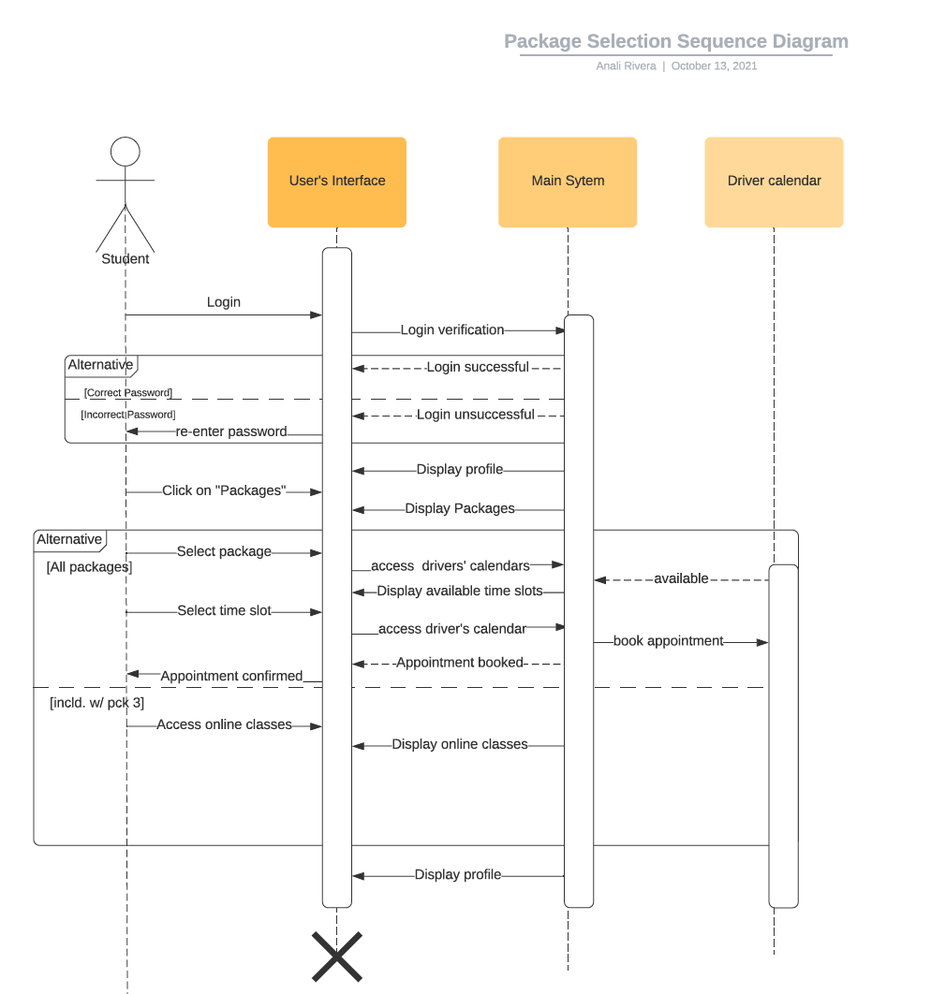

UML Class Diagram
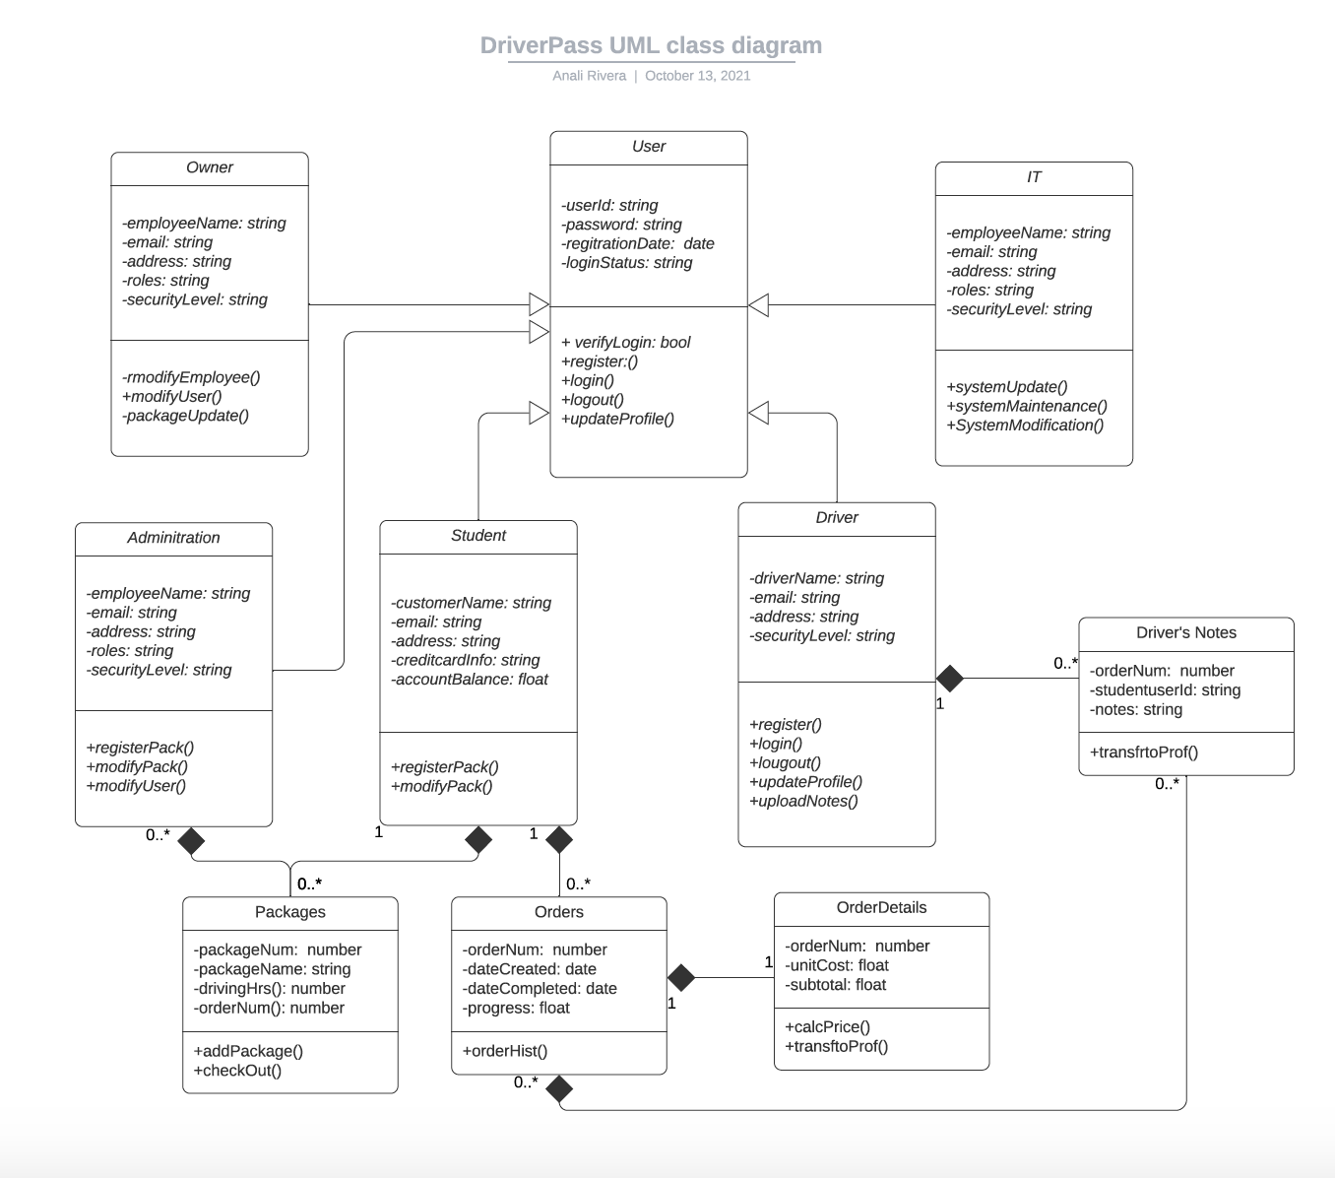

Technical Requirements
Based on the above diagrams, functional and non-functional requirements the technical requirements that I would recommend to DriverPass are as follows:
- The cloud could be used for data storage. This will not cost much and DriverPass can always upgrade their membership as their business expands.
- We will also need training for the employees including system administrators, secretary, and IT so they will know how to navigate the system and what their roles entails.
- The system could also be programmed in java in the backend and AngularJS in could be used for designing the front end, since this web-app is compatible with many browsers. Doing so could provide DriverPass with significant savings.

